|  |  |  |  |
| --- | --- | --- | --- |
| **Name:** | Maddara, Marlon V. | **Date:** | 11/03/2022 |
| **Program:** | BSCpE | **Section:** | A361 |

**Intended Learning Outcomes:**

1. Use simple and advanced styling methods such as fonts, colors, background images, and opacity.
2. Utilize positioning and pseudoclasses.

|  |
| --- |
| Duplicate (as identical as possible) the following website using HTML5 and CSS3 elements:   * Remove CPE104L and CPE121L as menu items and include CPE107 * For all “Inserts”, place actual images and necessary texts. Design your website properly. |

================================================================================

**HTML Source Code:**

|  |
| --- |
| <!DOCTYPE html>  <html>  <head>  <meta name="viewport" content="width=device-width, initial-scale=1">  <link rel="stylesheet" href="design.css"/>  <title>Laboratory Task 4</title>  </head>  <body>  <div class="header">  <h4>A Complete CSS Website</h4>  </div>  <nav>  <a class= "code" href="">CPE107</a>  <a class= "code" href="">CPE107L</a>  <a id= "CPE3">CPE 3</a>  </nav>  <div class="content">  <main>  <section class = "mcm">  <div class="card">  <h2>Malayan Colleges Mindanao</h2>  <h5>Excellence and Relevance</h5>  <img class="banner" src="banner.jpg"/>  <p class = "desc"><b>Malayan Colleges Mindanao (MCM)</b>, a branch encompassing Mapua University’s technological and academic excellence in Mindanao, has occupied a 3-hectare land area along Gen. Douglas MacArthur Highway, beside Matina Town Square in Matina, Davao City. The school officially began operations on July 2, 2018, and was followed by its official inauguration ceremony on July 7, 2018; inaugurated by President Rodrigo Roa Duterte and graced with the presence of Mayor Inday Sara Duterte; YGC Chairperson, Mrs. Helen Yuchengco-Dee; Mapua President, Dr. Reynaldo Vea; CHED Chairman, Dr. J. Prospero “Popoy” E. De Vera III, and MCM and MCL President and Chief Executive Officer, Dr. Dodjie Maestrecampo.<br><br>MCM has built a community of competent and innovative leaders who possess attributes that make them globally competitive and locally in-demand, distinguishing itself from the rest.</p>  </div>  </section>  <section class = "cea">  <div class="card">  <h2>College of Engineering and Architecture</h2>  <img class="banner" src="banner2.jpg"/>  <p class = "desc"><b>College of Engineering and Architecture (CEA)</b> transforms its graduates to become globally competitive, innovative leaders, socially responsible and result-oriented engineers and architects. MCM-CEA commits to educate students imbued with good moral and ethical values while engaging economically viable research and innovation that is relevant locally and beyond.<br><br>At CEA, students are primed and supervised by their adept mentors equipping students with profound knowledge and excellent skill-set through outcomes-based curricula in order for the students to have access to personalized learning allowing them to perform their best and achieve their academic and personal goals meeting local and global standards.<br><br>This kind of learning environment will upskill students to find state of the art solutions to the most challenging technological and socio-technological issues of different industries.</p>  </div>  </section>  </main>  <aside>  <section class = "about me">  <div class="card">  <h2>About Me</h2>  <img class="side" src="me.jpg"/>  <p class = "desc">My name is <b>Marlon V. Maddara</b>. I was born on August 31, 2001 in Saudi Arabia. I studied at the International Philippine School in Al-Khobar (IPSA), Saudi Arabia up until 3rd grade. I moved to the Philippines when I was just 9 years old and continued my studies at Notre Dame Siena College of Tacurong. I finished my 7th grade at NDSCT and then moved to Davao City to continue my education at the Ateneo de Davao University. I graduated my JHS and SHS at AdDU and I am now currently studying at Malayan Colleges Mindanao, taking up the course Computer Engineering.</p>  </div>  </section>  <section class = "favorite foods">  <div class="card">  <h3>Favorite Foods</h3>  <img class="side" src="1.jpg"/>  <b><p class = "caption">Pork Sisig</p></b>  <br>  <img class="side" src="2.jpg"/>  <b><p class = "caption">Baked Sushi</p></b>  <br>  <img class="side" src="3.jpg"/>  <b><p class = "caption">Oreo Icecream</p></b>  <br>  </div>  </section>  </aside>  </div>  <div class="footer">  <h5>Laboratory Task 4 - Advanced CSS Styling<br><br>CPE107L Software Design Laboratory</h5>  </div>  </body>  </html> |

**CSS Source Code:**

|  |
| --- |
| /* Responsive layout - when the screen is less than 800px wide, make the two columns stack on top of each other instead of next to each other */  @media screen and (max-width: 800px) {  .leftcolumn, .rightcolumn {  width: 100%;  padding: 0;  }  }  * {  box-sizing: border-box;  }  body {  background: #e7e7e7;  font-family: arial;  padding: 7.5px;  }  .header {  background: white;  text-align: center;  padding: 30px;  font-size: 40px;  }  nav{  background: #204656;  padding: 10px;  }  .code{  text-decoration: none;  color: white;  padding-right: 20px;  }  #CPE3{  float: right;  color: white;  }  main {  float: left;  width: 75%;  }  .desc {  text-align: justify;  }  aside {  float: left;  width: 25%;  padding-left: 20px;  }  .card {  background-color: white;  padding: 20px;  margin-top: 20px;  }  .banner {  width: 100%;  height: 600px;  object-fit: cover;  object-position: center;  }  .side {  width: 100%;  height: 280px;  object-fit: cover;  object-position: center;  }  img {  border: 0.5px solid #555;  }  .caption {  text-align: center;  }  .content:after {  content: "";  display: table;  clear: both;  }  .footer {  background: #204656;  color: white;  text-align: center;  padding: 20px;  margin-top: 20px;  } |

**Output:**

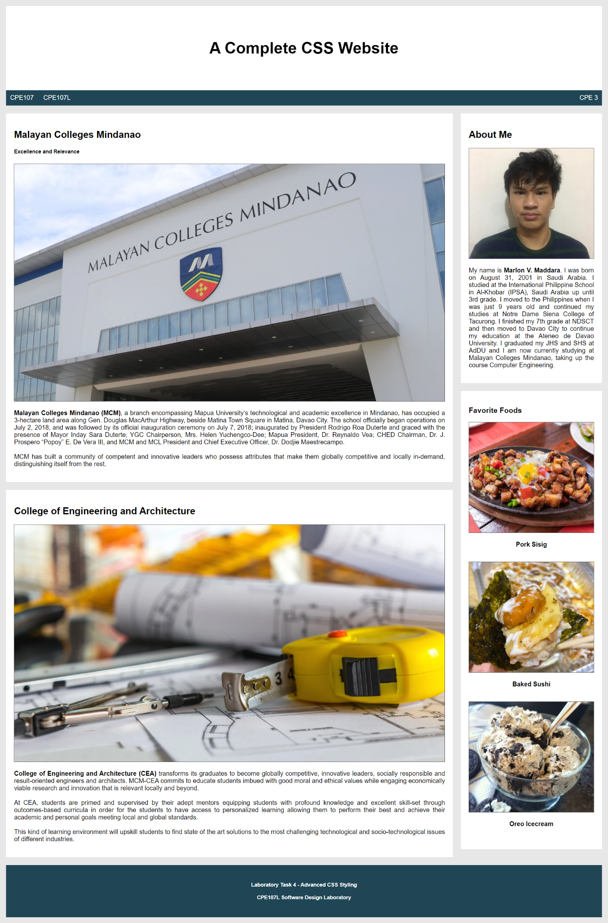

**Findings and Observations:**

|  |
| --- |
|  |